Archie Goodwin (fictional detective)
From Wikipedia, the free encyclopedia
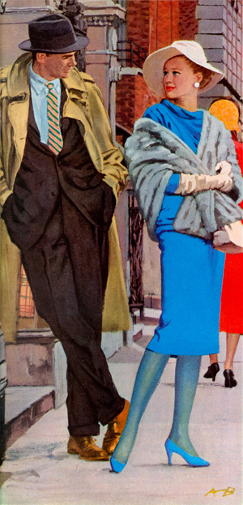
Archie Goodwin meets Flora Gallant in part one of
Rex Stout's "Frame-Up for Murder," illustrated by
Austin Briggs for The Saturday Evening Post (June 21, 1958)
Archie Goodwin is a fictional character and detective in Rex Stout's Nero Wolfe mysteries. The witty voice of all the stories, he recorded the cases of the detective genius from 1934 (Fer-de-Lance) to 1975 (A Family Affair). He lives in Nero Wolfe's brownstone in New York City.
Archie was born on October 23^{[1]} in Chillicothe, Ohio, but moved to Zanesville by age 12.^{[2]} In Fer-de-Lance we learn that Archie's parents died when he was still a child, but in The Final Deduction both Archie and Wolfe refer to Archie's mother as still alive; in The Rubber Band we find that Archie has a sister who once gave him silk pajamas for Christmas.

Character
I know pretty well what my field is. Aside from my primary function as the thorn in the seat of Wolfe's chair to keep him from going to sleep and waking up only for meals, I'm chiefly cut out for two things: to jump and grab something before the other guy can get his paws on it, and to collect pieces of the puzzle for Wolfe to work on.
— Archie Goodwin in The Red Box (1937), chapter 12
Archie is Wolfe's live-in assistant in the private investigation business Wolfe runs out of his brownstone townhouse in New York City. Wolfe rarely leaves the house, so Archie does most of the actual investigating, followed by reporting his findings to Wolfe, who solves the mystery. Archie has trained his memory so that he can make verbatim reports, oral or typewritten, of extended conversations.
He also does Wolfe's bookkeeping and banking, types his correspondence, and keeps the germination and other records for the orchids Wolfe raises as a hobby. Archie's hobbies include dancing (usually at the Flamingo), poker, and baseball. He was a fan of the New York Giants until they relocated to San Francisco in 1957, then later became a fan of the New York Mets when that team was founded in 1962.
Although he is from the American Midwest, Archie has the "street smarts" to handle just about any situation he finds himself in, and he knows New York City like the back of his hand. Though he freely admits that there is no one better than Saul Panzer in many aspects of investigative work, such as remembering faces and tailing people, Goodwin is one of the most competent private detectives in the city. He has a long-time social relationship with Lily Rowan, a wealthy society woman, but they do not try to limit each other's social lives.
Archie has had relationships with Celia Grantham and Lucy Armstead-Valdon. He also exhibited affection for Beulah Page, Phoebe Gunther, Priscilla Eads, Sally Leeson, and Julie Jaquette.
Unlike his employer, Archie has only one conspicuous eccentricity: his favorite drink is milk.
When Wolfe leaves the brownstone after escalating threats from villain Arnold Zeck, Archie rents an office of his own and works as an independent detective. During this time, he manages to earn more than Wolfe had paid him—not because he needs more money, but as a matter of principle to confirm to himself that his long-term loyalty to Wolfe was not due to any inability to function on his own. Naturally, after Archie and Wolfe have arranged for one of Zeck's victims to kill Zeck, they return to their prior relationship with a deepened appreciation for their mutual loyalties.

Portrayals
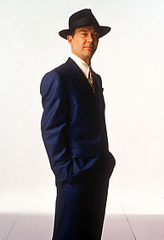
Timothy Hutton portrayed
Archie Goodwin in A&E TV's
A Nero Wolfe Mystery
(Andrew Eccles)
- Lionel Stander in the Columbia Pictures films Meet Nero Wolfe (1936) and The League of Frightened Men (1937)
- John Gibson in the 1943–1944 radio series The Adventures of Nero Wolfe
- Elliott Lewis in the 1946 radio series The Amazing Nero Wolfe
- Gerald Mohr, Herb Ellis, Lawrence Dobkin, Harry Bartell, Lamont Johnson and Wally Maher in the 1950–1951 radio series The New Adventures of Nero Wolfe
- Gene Reynolds in the 1956 Omnibus TV series episode, "The Fine Art of Murder"
- Joachim Fuchsberger in the 1961 German TV movie Zu viele Köche
- Paolo Ferrari in the 1969–1971 Italian TV series
- Tom Mason in the 1977 TV movie Nero Wolfe
- Lee Horsley in the 1981 TV series Nero Wolfe
- Don Francks in the 1982 Canadian radio series Nero Wolfe
- Timothy Hutton in the A&E TV movie The Golden Spiders: A Nero Wolfe Mystery (2000)
- Sergey Zhigunov in the 2001–2002 Russian TV movies
- Timothy Hutton in the 2001–2002 A&E TV series A Nero Wolfe Mystery

Influence
- In the Bernie Rhodenbarr series by Lawrence Block, Bernie's friend Carolyn Kaiser owns a cat named Archie Goodwin, named after the detective.

External links
 | Wikiquote has a collection of quotations related to: Nero Wolfe
- The Wolfe Pack, official site of the Nero Wolfe Society
- Nero Wolfe and Archie Goodwin, site about Nero Wolfe in russian

References
  - ^ The League of Frightened Men (1935), chapter 12: "I had a nice piece of leather of my own, not as big as Paul Chapin's treasure box, but fancier. Sitting at my desk around five o'clock that Wednesday afternoon, killing time waiting for a visitor who had phoned, I took it out of my inside breast pocket and looked at it; I had only had it a couple of weeks. It was brown, ostrich-skin, and was tooled in gold all over the outside. On one side the tooling was fine lines about half an inch apart, with flowers stemming out from them; the flowers were orchids; the workmanship was so good that you could tell Wolfe had given the guy a Cattleya to work from. The other side was covered with Colt automatics, fifty-two perfect little gold pistols all aiming at the center. Inside was stamped in gold: 'A.G. from N.W.' Wolfe had given it to me on October 23rd, at the dinner-table, and I didn't even know he knew when my birthday was."
  - ^ The Silent Speaker, Chapter 10.

